**Name: Merlin Moncy**

**Roll No:21**

**Batch: MCA-B**

**Date:21-03-2022**

**NETWORKING & SYSTEM ADMINISTRATION LAB**

**Experiment No.: 1**

**Aim**

Install the latest version of Ubuntu on an Oracle VM VirtualBox.

**Procedure**

Below are the very easy steps with screenshots containing the installation procedure of Virtual Box.

**Output Screenshot**

Step 1: click next.

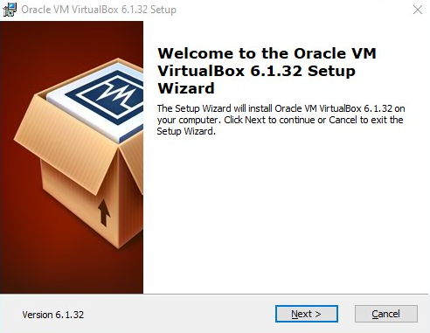

Step 2:click next.

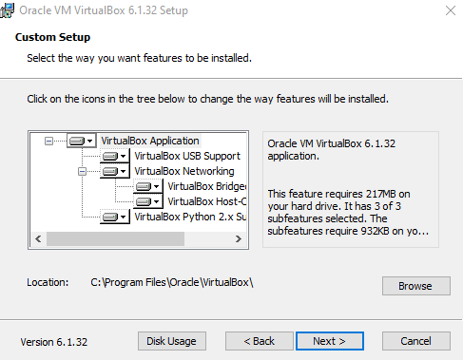

Step 3: click next.

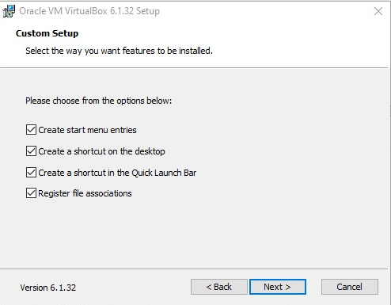

Step 4: click yes.

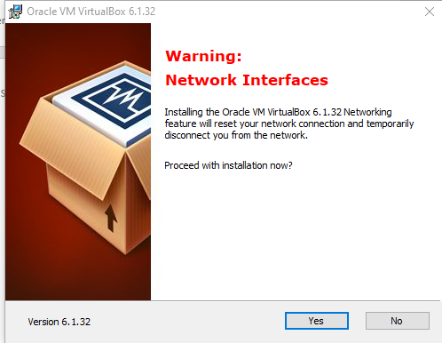

Step 5: click install.

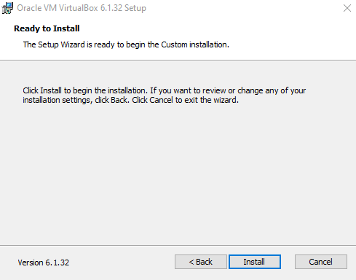

Step 6: install.

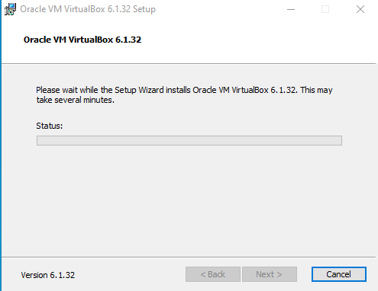

Step 7: finish

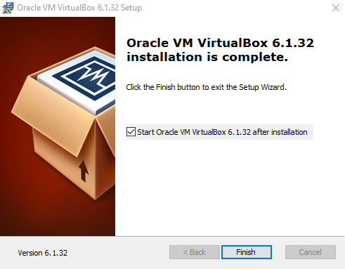

### Step 8: Click on “New” to create a virtual machine.

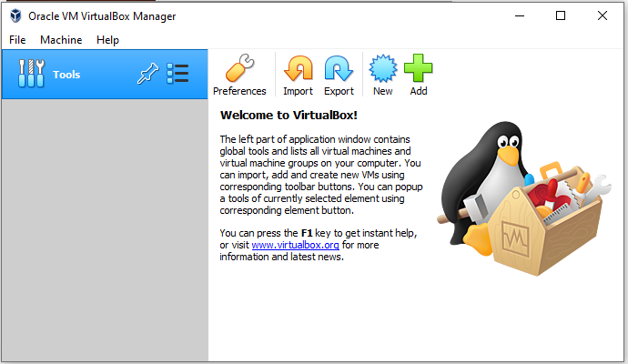

### Step 9: Enter Name for your Virtual Machine

### 

### Step10: Enter amount of memory (RAM) =1024 MB and click “Next”

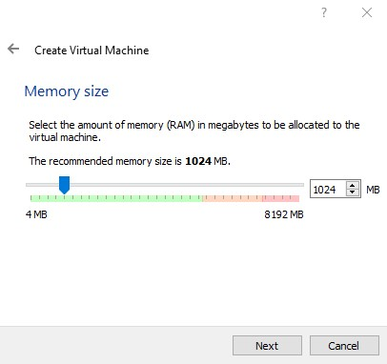

### Step11: Click “Create” to create hard drive

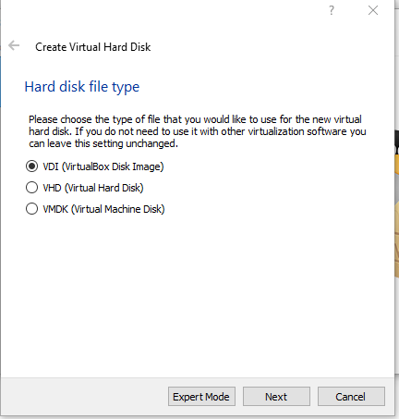

Step 12: click next

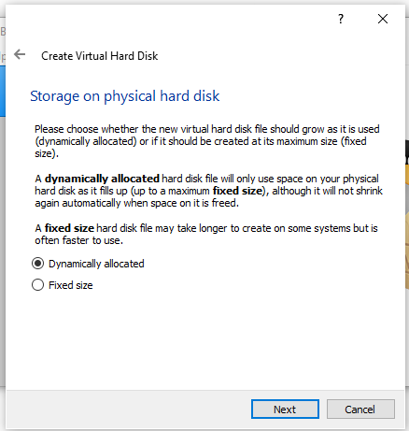

### Step13: Enter Size of Virtual Hard Drive= 20 GB and Click “Create”

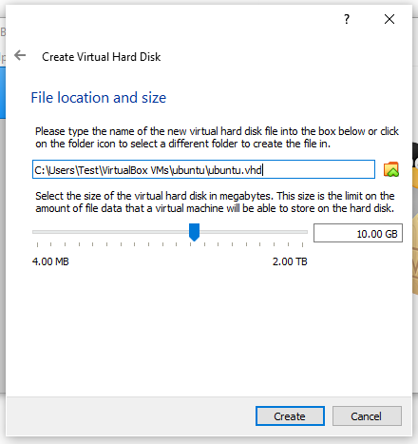

### Step14: Select Virtual Machine

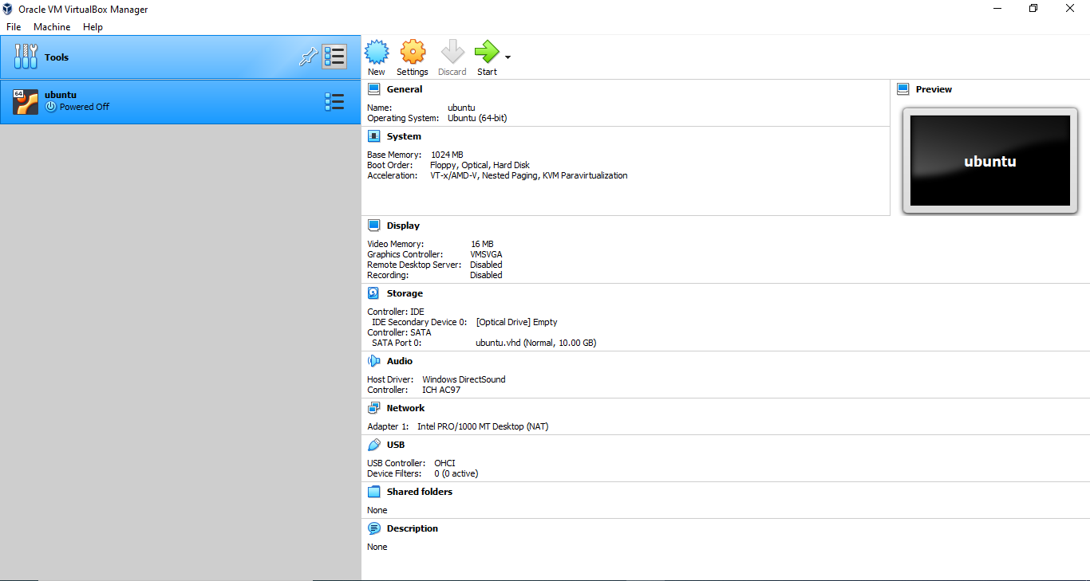

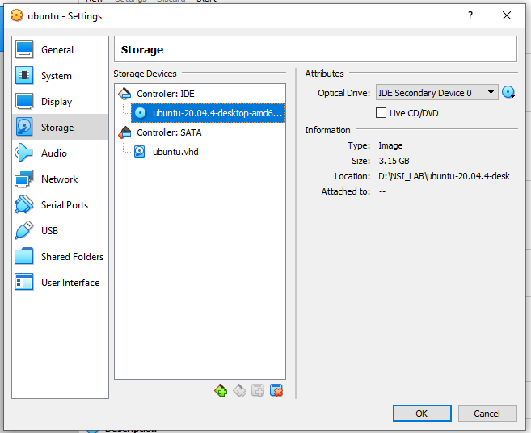

Step15: Click “Install Ubuntu”

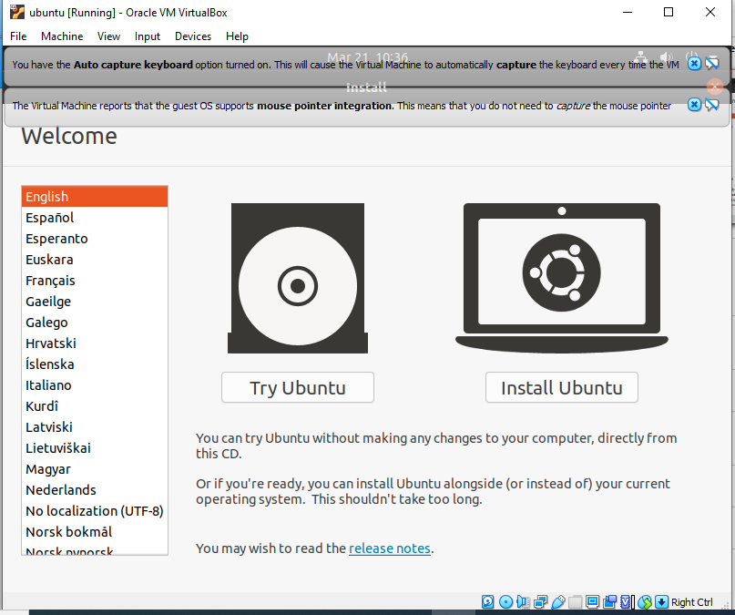

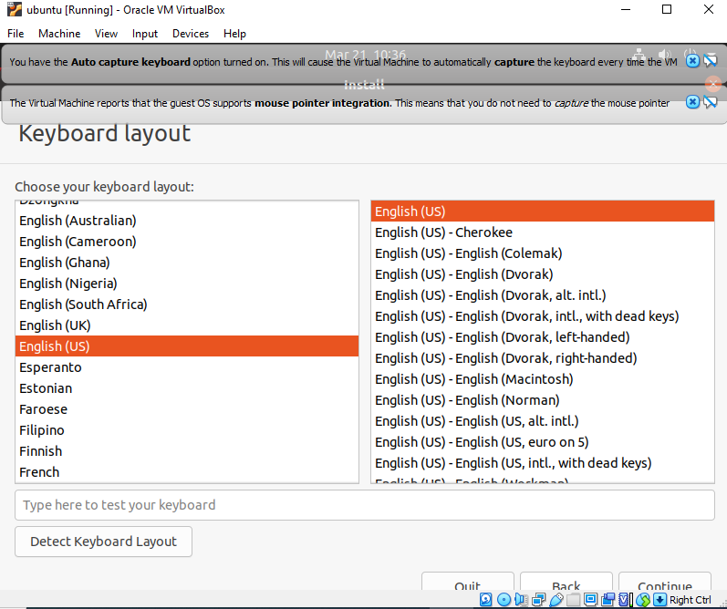

### Step16:Click “Continue”

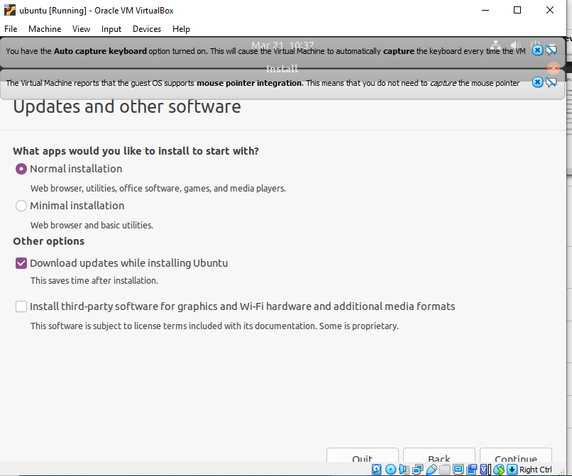

### Step17:Select location and click “Continue”

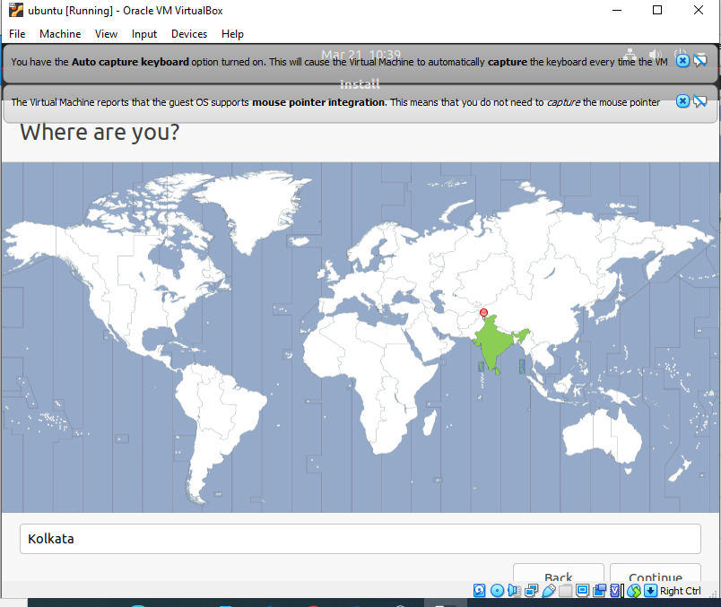

### Step18:Fill all the details and Click “Continue”

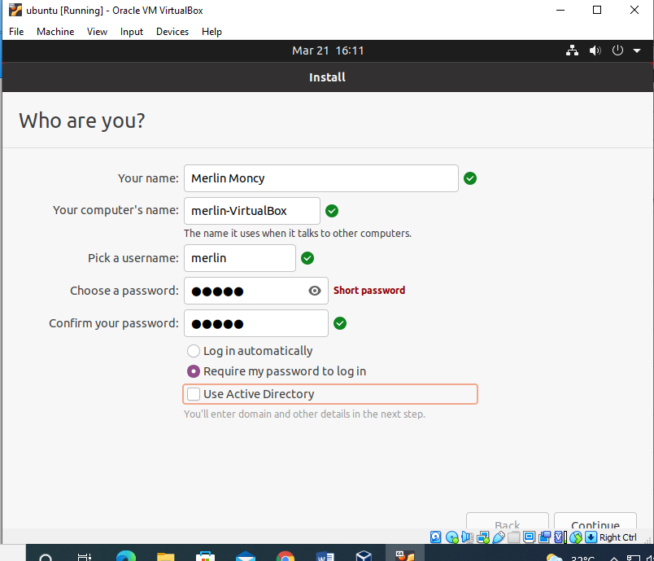

### Step19: Now the installation process will start and installation window will appear.

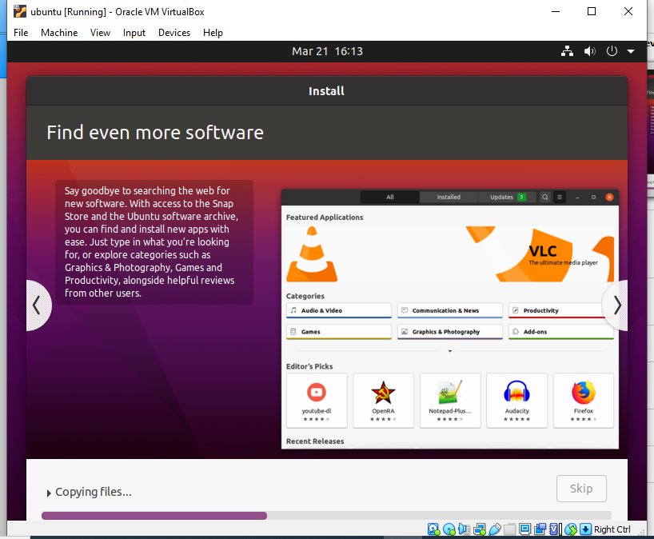

Step20: Click “Restart Now”.

